

# 

### Semester One Examination, 2020

# MATHEMATICS

**QUESTIONS**

**METHODS**

**UNIT 3**

## Section Two:

## Calculator-assumed

## Structure of this paper

|  |  |  |  |  |  |
| --- | --- | --- | --- | --- | --- |
| Section | Number of questions available | Number of questions to be answered | Working time (minutes) | Marks available | Percentage of examination |
| Section One: Calculator-free | 8 | 8 | 50 | 52 | 35 |
| Section Two: Calculator-assumed | 13 | 13 | 100 | 98 | 65 |
|  | | |  | **Total** | 100 |

This section has**thirteen** questions.

Question 9 (6 marks)

A seafood processor buys batches of $n$ prawns from their supplier, where $n$ is a constant. In any given batch, the probability that a prawn is export quality is $p$, where $p$ is a constant and the quality of an individual prawn is independent of other prawns.

The discrete random variable $X$ is the number of export quality prawns in a batch and the mean of $X$ is $220.5$ and standard deviation of $X$ is $5.25$.

(a) State the name given to the distribution of $X$ and determine its parameters $n$ and $p$.

(4 marks)

(b) Determine the probability that less than $90\%$ of prawns in a randomly selected batch are export quality. (2 marks)

Question 10 (8 marks)

A small body moving in a straight line has displacement $x$ cm from the origin at time $t$ seconds given by

$$x=4\cos\left(3t-6\right)-1.5, 0≤t≤3.$$

(a) Use derivatives to justify that the maximum displacement of the body occurs when $t=2$.

(4 marks)

(b) Determine the time(s) when the velocity of the body is not changing. (2 marks)

(c) Express the acceleration of the body in terms of its displacement $x$. (2 marks)

Question 11 (8 marks)

The voltage, $V$ volts, supplied by a battery $t$ hours after timing began is given by

$$V=14.9e^{-0.355t}$$

(a) Determine

(i) the initial voltage. (1 mark)

(ii) the voltage after $1.9$ hours. (1 mark)

(iii) the time taken for the voltage to reach $0.01$ volts. (1 mark)

(b) Show that $\begin{matrix}dV \\ \overline{dt}\end{matrix}=aV$ and state the value of the constant $a$. (2 marks)

(c) Determine the rate of change of voltage $1.9$ hours after timing began. (1 mark)

(d) Determine the time at which the voltage is decreasing at $2\%$ of its initial rate of decrease.

(2 marks)

Question 12 (7 marks)

The function $f$ is defined as $f\left(x\right)=\begin{matrix}5e^{0.2x} \\ \overline{ x }\end{matrix} , x>0$, and the graph of $y=f(x)$ is shown below.

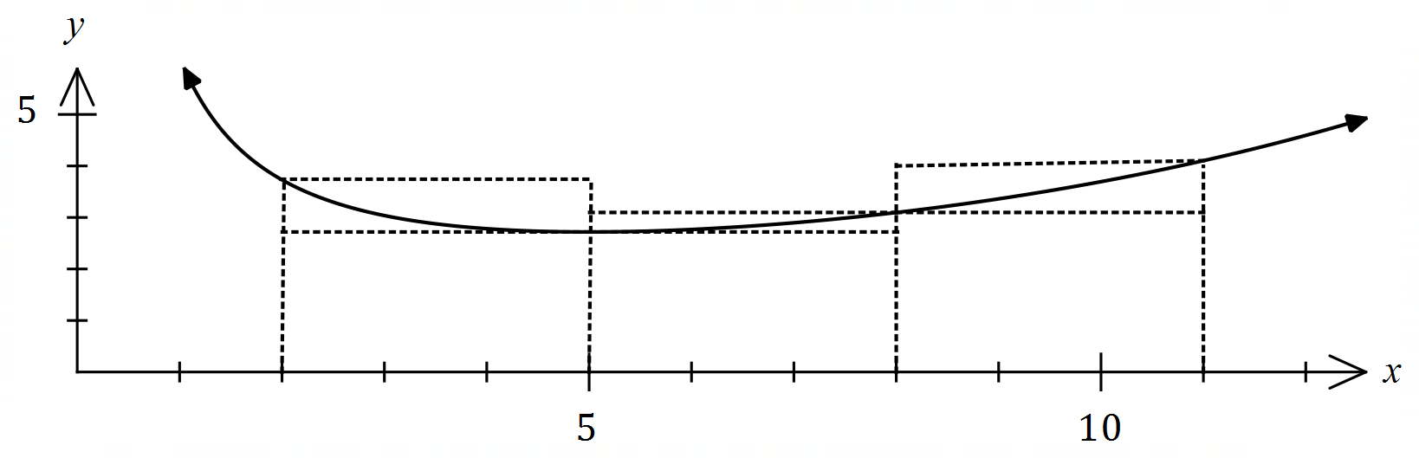

(a) Complete the missing values in the table below, rounding to $2$ decimal places. (1 mark)

|  |  |  |  |  |
| --- | --- | --- | --- | --- |
| $$x$$ | $$2$$ | $$5$$ | $$8$$ | $$11$$ |
| $$f(x)$$ |  |  | $$3.10$$ | $$4.10$$ |

(b) Use the areas of the rectangles shown on the graph to determine an under- and over-estimate for $\int_{2}^{11}{\underset{ }{\overset{ }{f(x)}}}dx$. (3 marks)

(c) Use your answers to part (b) to obtain an estimate for $\int_{2}^{11}{\underset{ }{\overset{ }{f(x)}}}dx$. (1 mark)

(d) State whether your estimate in part (c) is too big or too small and suggest a modification to the numerical method employed to obtain a more accurate estimate. (2 marks)

Question 13 (8 marks)

A bag contains four similar balls, one coloured red and three coloured green. A game consists of selecting two balls at random, one after the other and with the first replaced before the second is drawn. The random variable $X$ is the number of red balls selected in one game.

(a) Complete the probability distribution for $X$ below. (3 marks)

|  |  |  |  |
| --- | --- | --- | --- |
| $$x$$ | $$0$$ | $$1$$ | $$2$$ |
| $$P(X=x)$$ |  |  |  |

(b) Determine $E(X)$ and $\operatorname{Var}{(X)}$. (2 marks)

(c) A player wins a game if the two balls selected have the same colour. Determine the probability that a player wins no more than three times when they play five games.

(3 marks)

Question 14 (8 marks)

A curve has equation $y=\left(x-3\right)e^{2x}$.

(a) Show that the curve has only one stationary point and use an algebraic method to determine its nature. (3 marks)

(b) Justify that the curve has a point of inflection when $x=2$. (3 marks)

(c) Sketch the curve on the axes below. (2 marks)

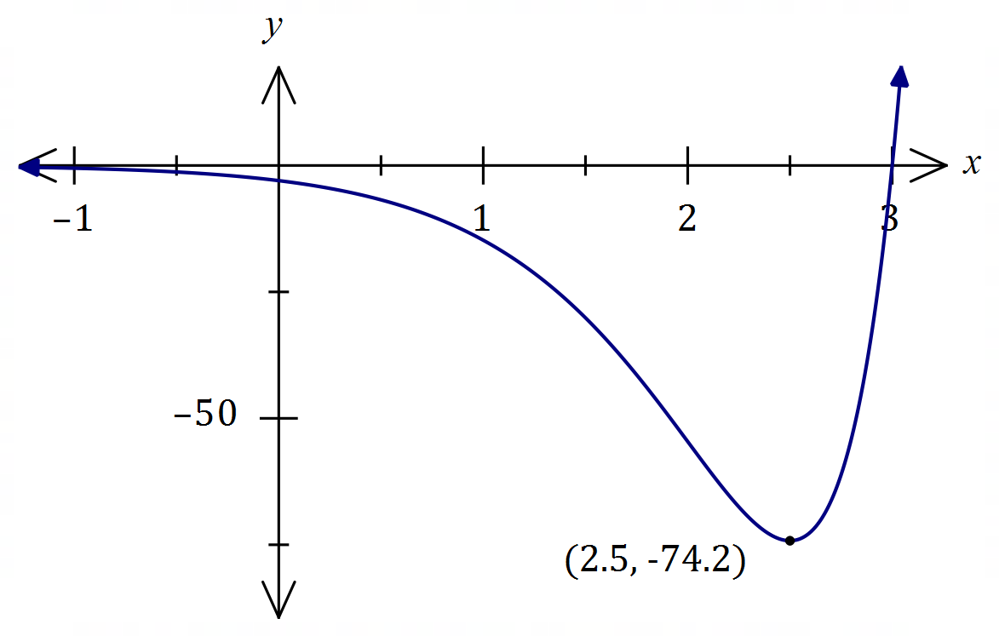

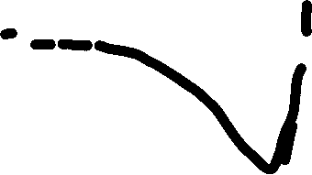

Question 15 (9 marks)

A small body leaves point $P$ and travels in a straight line for $24$ seconds until it reaches point $Q$.

The velocity $v$ m/s of the body is shown in the graph below for $0≤t≤24$ seconds.

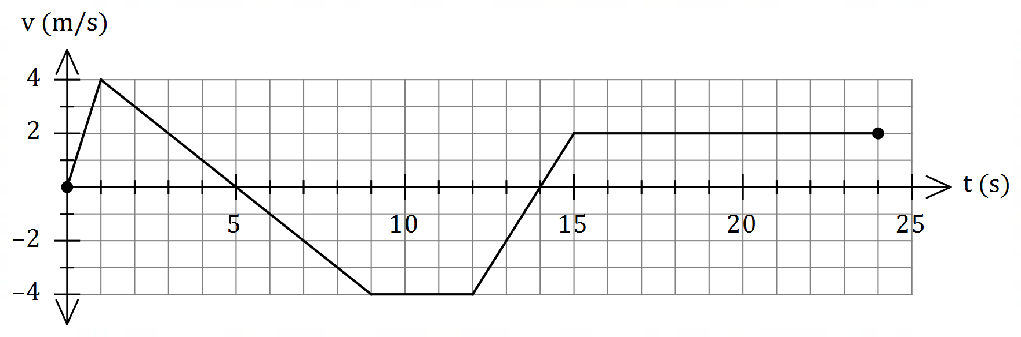

(a) Use the graph to evaluate $\int_{0}^{5}{\underset{ }{\overset{ }{v}}}dt$ and interpret your answer with reference to the motion of the small body. (3 marks)

(b) Determine an expression, in terms of $t$, for the displacement of the body relative to $P$ during the interval $1≤t≤9$. (3 marks)

(c) Determine the time(s) at which the body was at point $P$ for $0<t≤24$. (3 marks)

Question 16 (9 marks)

When a machine is serviced, between $2$ and $6$ of its parts are replaced. Records indicate that $28\%$ of machines need $4$ parts replaced, $13\%$ need $5$ parts replaced, $5\%$ need $6$ parts replaced, and the mean number of parts replaced per service is $3.54$.

Let the random variable $X$ be the number of parts that need replacing when a randomly selected machine is serviced.

(a) Complete the probability distribution table for $X$ below. (4 marks)

|  |  |  |  |  |  |
| --- | --- | --- | --- | --- | --- |
| $$x$$ | $$2$$ | $$3$$ | $$4$$ | $$5$$ | $$6$$ |
| $$P(X=x)$$ |  |  |  |  |  |

(b) Determine $Var⁡(X)$. (2 marks)

The cost of servicing a machine is $\$85$ plus $\$26.50$ per part replaced and the random variable $Y$ is the cost of servicing a randomly selected machine.

(c) Determine the mean and standard deviation of $Y$. (3 marks)

Question 17 (6 marks)

Some values of the polynomial function $f$ are shown in the table below:

|  |  |  |  |  |  |  |  |
| --- | --- | --- | --- | --- | --- | --- | --- |
| $$x$$ | $$1$$ | $$2$$ | $$3$$ | $$4$$ | $$5$$ | $$6$$ | $$7$$ |
| $$f(x)$$ | $$16$$ | $$13$$ | $$8$$ | $$2$$ | $$-2$$ | $$1$$ | $$5$$ |

(a) Evaluate $\int_{1}^{6}{\underset{ }{\overset{ }{f'(x)}}}dx$. (2 marks)

The following is also known about $f'(x)$:

|  |  |  |  |
| --- | --- | --- | --- |
| Interval | $$1≤x≤5$$ | $$x=5$$ | $$5≤x≤7$$ |
| $$f'(x)$$ | $$f^{'}\left(x\right)<0$$ | $$f^{'}\left(x\right)=0$$ | $$f^{'}\left(x\right)>0$$ |

(b) Determine the area between the curve $y=f'(x)$ and the $x$-axis, bounded by $x=2$ and $x=7$. (4 marks)

Question 18 (8 marks)

Let $P(a, b)$ be a point in the first quadrant that lies on the curve $y=5-x^{2}$ and $A$ be the area of the triangle formed by the tangent to the curve at $P$ and the coordinate axes.

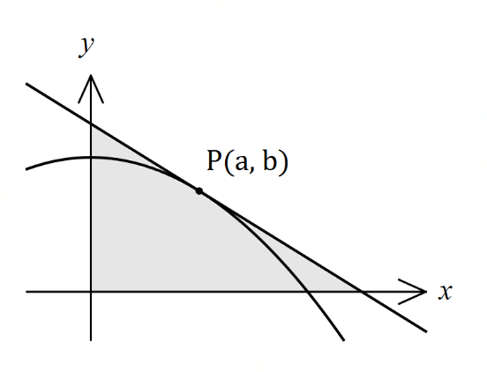

(a) Show that $A=\begin{matrix}{\left(a^{2}+5\right)}^{2} \\ \overline{ 4a }\end{matrix}$. (4 marks)

(b) Use calculus to determine the coordinates of $P$ that minimise $A$. (4 marks)

Question 19 (7 marks)

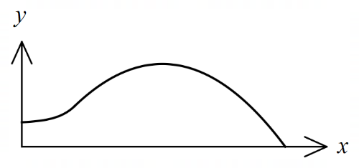The edges of a swimming pool design, when viewed  
from above, are the $x$-axis, the $y$-axis and the curves

$y=-0.1x^{2}+1.6x-1.5$ and $y=1.4+e^{x-3}$

where $x$ and $y$ are measured in metres.

(a) Determine the gradient of the curve at the point where the two curves meet. (2 marks)

(b) Determine the surface area of the swimming pool. (4 marks)

(c) Given that the water in the pool has a uniform depth of $145$ cm, determine the capacity of the pool in kilolitres ( $1$ kilolitre of water occupies a volume of m3). (1 mark)

Question 20 (6 marks)

Given that $f\left(3\right)=9, f^{'}\left(3\right)=-6, g\left(3\right)=-2$ and $g^{'}\left(3\right)=4$, evaluate $h'(3)$ in each of the following cases:

(a) $h\left(x\right)=g\left(x\right)⋅f(x)$. (2 marks)

(b) $h\left(x\right)=g\left(\sqrt{f\left(x\right)}\right)$. (4 marks)

Question 21 (8 marks)

When a byte of data is sent through a network in binary form (a sequence of bits - $0$'s and $1$'s), there is a chance of bit errors that corrupt the byte, i.e. a $0$ becomes a $1$ and vice versa.

Suppose a byte consists of a sequence of $9$ bits and for a particular network, the chance of a bit error is $0.200\%.$

(a) Determine the probability that a byte is transmitted without corruption, rounding your answer to $5$ decimal places. (3 marks)

(b) Determine the probability that during the transmission of $128$ bytes, at least one of the bytes becomes corrupted. (2 marks)

A Hamming code converts a byte of $9$ bits into a byte of $13$ bits for transmission, with the advantage that if just one bit error occurs during transmission, it can be detected and corrected.

(c) Determine the probability that during the transmission of $128$ bytes using Hamming codes, at least one of the bytes becomes permanently corrupted. (3 marks)

Supplementary page

Question number: _________